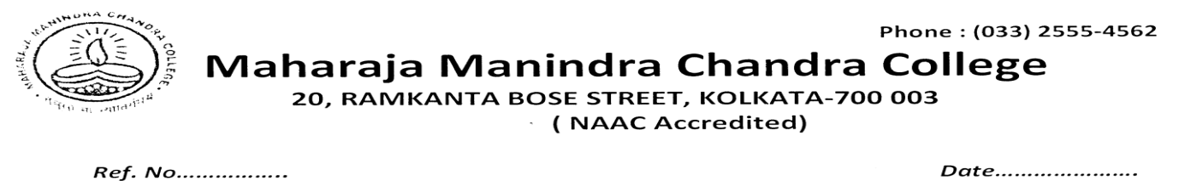
NOTICE

A special meeting of the Anti Ragging Sub-Committee is going to be conducted on 29/05/2023 at 8 pm via Google meet platform to transact the following issues:
AGENDA 1: To discuss/report the cases of ragging, if any, since the last meeting held on 15.9.2021 through the end of the academic session 2021-2022 and beginning of the academic session 2022-2023 till date.
- Miscellaneous.

Honourable members are requested to attend this meeting positively.

Link for the meeting will be shared in sue course.

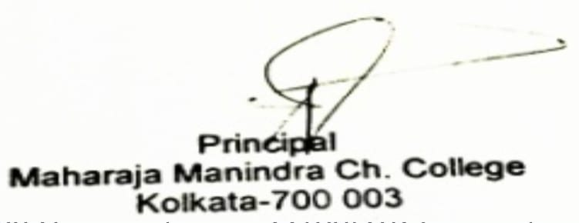

Dated. 24/05/23

